Elections 2023 | 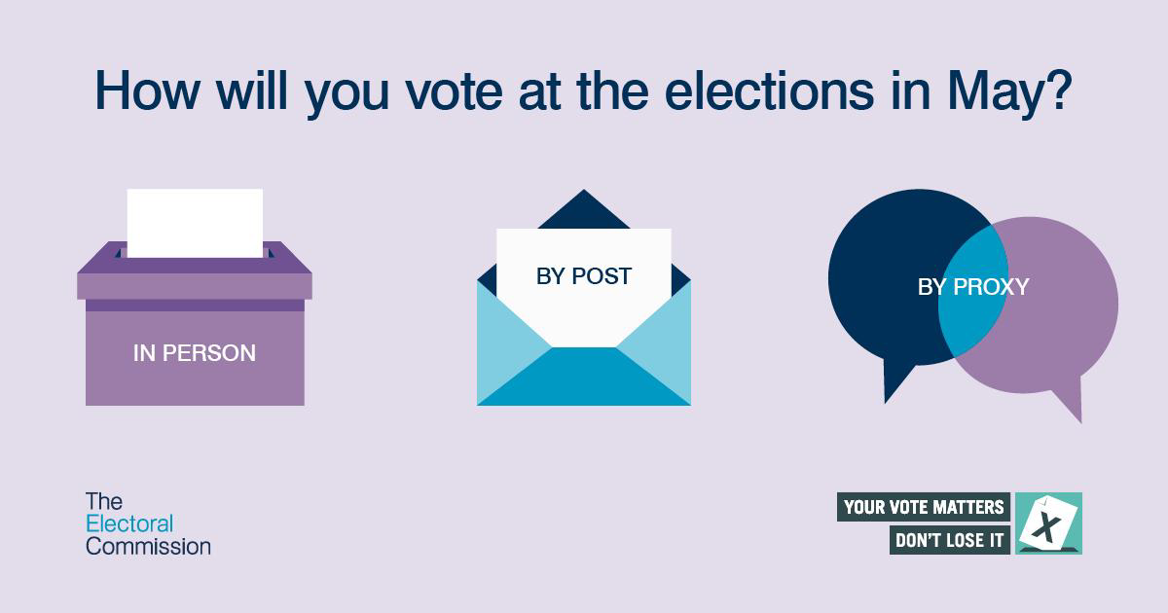
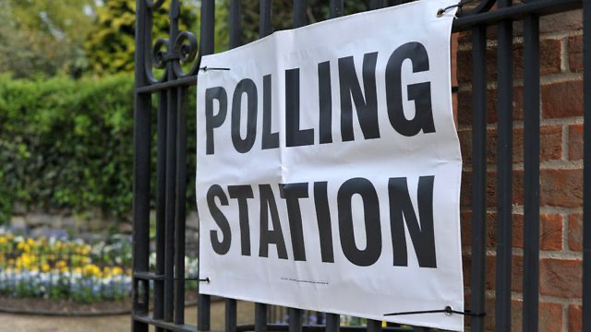 | 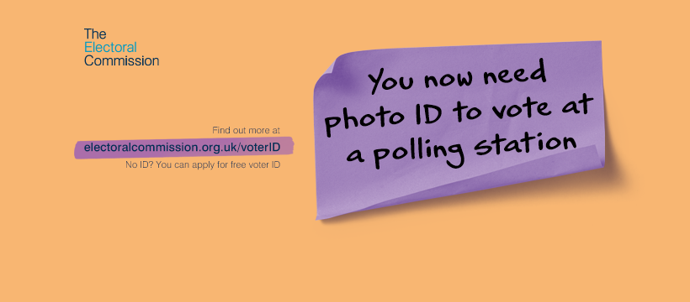
  - Broadland District and South Norfolk Councils’ elections, including Parish/Town Councils
  - Thursday 4 May 2023

  - Briefing note for candidates and agents

Version 1 –created 30 January 2023

The People

The Returning Officer for Broadland District and South Norfolk Councils

Returning Officer (RO) – Trevor Holden – md@southnorfolkandbroadland.gov.uk

The Deputy Returning Officers for Broadland District and South Norfolk Councils

Trevor has appointed the following deputies, with full powers:

Deputy RO - Emma Hodds – emma.hodds@southnorfolkandbroadland.gov.uk

Deputy RO – Linda Mockford – linda.mockford@southnorfolkandbroadland.gov.uk

Deputy RO – Nicola Tullock – nicola.tullock@southnorfolkandbroadland.gov.uk

Queries relating to the election should be directed to:
Election helpline: 01603 430483
elections@southnorfolkandbroadland.gov.uk

Key Dates

Key Dates

20 February @ 4:30pm - District Agent and Candidate Briefing – on Zoom

27 February @ 5pm – Parish and Town – clerk and candidate briefing – on Zoom

Publication of Notice of Election 16 March

Delivery of nominations

between the hours of 9am and 4pm from 17 March deadline 4pm - 4 April

Deadline for the appointment of an election agent (n/a parishes) 4pm – 4 April

Deadline for Publication of Statement of Persons Nominated 4pm – 5 April

Deadline to register to vote (for those currently not registered) 17 April

Deadline for receiving new postal or postal proxy votes,

or changes to existing applications 5pm – 18 April

Deadline for receiving new proxy vote applications 5pm - 25 April

Deadline for Voter Authority Certificates (VAC) applications 5pm – 25 April

Deadline for appointing counting agents 26 April

Election day 7am – 10pm 4 May

Deadline for emergency proxy votes 5pm - 4 May

Key information

District and parish/town council elections
Broadland District Council, South Norfolk Council and all of the parish/town councils in the districts elect all of their councillors every four years. The last district and parish/town council elections were held in 2019.

Broadland District Council
Broadland District Council has 47 councillors representing 27 electoral wards and there are 51 parish and town councils in the district.

South Norfolk Council
South Norfolk Council has 46 councillors representing 26 wards and there are 100 parish and town councils in the district.

Notice of Election
The Notice of Election for the district and parish elections will be published on Thursday 16 March 2023. This denotes the start of the pre-election period.

Poll cards
Poll cards should be posted out from Friday 17 March. This first batch of cards will include all those electors that are currently registered. There will be a later despatch for those that register after 6 March and up to the registration deadline of 17 April. These will be posted out around 25 April.

Nominations
Nomination forms can be delivered on working days between the hours of 9am – 4pm from 17 March – 4 April. The absolute deadline for delivering nomination forms is 4pm on Tuesday 4 April. However, we recommend not leaving it until the deadline, in case the papers contain errors as you run the risk of not being able to submit a valid nomination on time.
There have been changes to nominations and the number of signatures required to sign District nomination papers has now been reduced to two signatures (proposer and seconder). Parish nominations remain unchanged at two signatures. Candidate guidance and the new nomination packs are available on the Electoral Commission (EC) website under the following links:

District Council:

https://www.electoralcommission.org.uk/i-am-a/candidate-or-agent/local-elections-england
Parish councils:
https://www.electoralcommission.org.uk/i-am-a/candidate-or-agent/parish-council-elections-england
Home address form

Candidates not wishing for their home address to be made public, must complete Part 2 of the home address form. The relevant area is the name of the district council where the candidate is registered to vote.
If candidates complete Part 2, their home address will not appear on the statement of persons nominated or the ballot paper. However, candidates should note that if they are elected as a Councillor, their details will be passed to Democratic Services (parish/town candidates details will be passed to the parish/town clerk) and their address will be published on the Councils’ website and on the register of interests form (unless granted an exemption).

Certificate of authorisation
Candidates standing on behalf of a registered political party will need a certificate of authorisation to use the party description and emblem, signed by the registered Nominating Officer of the party or by a person authorised to sign on their behalf.

Please ensure that the elections team have up to date certificates, as many have now expired.

Anyone wishing to have an informal check of their nominations before they formally submit them, can email their form to the elections team (contact details given at end of this briefing note).

Delivery of nominations

Nominations must be HAND DELIVERED (not necessarily by the candidate) to the following address:
The Horizon Centre (annex), Broadland Business Park, Peachman Way, Norwich, NR7 0WF.
Nominations sent by post cannot be accepted.

Statement of Persons Nominated
A list of candidates standing (the statement of persons nominated) for each district ward and parish/town, will be published by 4pm on Wednesday 5 April. Where there are insufficient nominations received for a particular area, all validly nominated candidates will be elected unopposed.

Register to vote
For those residents not currently registered to vote, the deadline for registering to vote at this election is Monday 17 April.

Postal voting
The deadline for applying for a postal vote, including postal proxies, is 5pm on Tuesday 18 April 2023.
The bulk of the postal votes will be sent out on 18 April – this will include long term postal voters, including those voters that have applied to vote by post up until 31 March. A further batch will be sent out around 24 April (to those electors that have applied for postal voters after 31 March).
Due to the complexity of the combined election, separate postal vote packs will be sent for each election (i.e. one pack for district and a separate pack for parish). The district ballot paper will be printed on white paper and the parish paper will be printed on green paper.

Proxy votes

The deadline for applying for a proxy vote is 5pm on Tuesday 25 April.

The deadline for applying for an emergency proxy vote is 5pm on Thursday 4 May 2023. This provision is for voters that require a proxy for emergency health or work reasons, and the reason only occurred after 5 pm 18 April.

There will be a new provision for an emergency proxy related to Voter ID for those whose ID is lost, stolen or damaged after the VAC application deadline.

Voter Authority Certificates (VAC)
New legislation has been introduced that requires voters to show photographic ID if they wish to vote at polling stations. For those electors that don’t have accepted forms of ID, they can apply for a free voter ID document, which is known as a Voter Authority Certificates (VAC). The deadline for applying for a VAC is 5pm on Tuesday 25 April.

Count
The count for the District and Parish elections will take place at the Arena, Norfolk Showground, Dereham Road, Norwich, NR5 0TT on Friday 5 May @ 9am. It is anticipated that the count will last all day and further details will be made available in April.
The candidate and their partner may attend the count. The district candidates may also appoint a counting agent(s) and their election agent can also attend.

Contact details
Contact details for the elections team:

Telephone: 01603 430483

Email: elections@southnorfolkandbroadland.gov.uk

